ZX10/ZX14 Wheel Conversion Kit
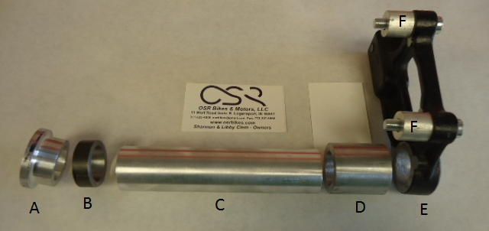
Instructions: Picture is show Left to Right as if sitting on the bike. Remove old bearings and crush tube from the ZX10 wheel. Install included bearings and crush tube back into ZX10 wheel and you are ready to install rear wheel. The front wheel is pretty much a direct swap – all you need to do is install the ZX14 rotors onto the ZX10 wheels. Also included in kit but not pictured are 2 Bearings. The bearings go in the rear wheel. You will reuse the bearing in the sprocket carrier as it fits the ZX14 axle.
A: Left Side Outer Sprocket Spacer
B: Left Inner Sprocket Spacer (during installation you may need a long screwdriver to hold this up while pushing the axle through.
C: Inner Crush Tube
D: Right Side Spacer ** Note- you do not use the stock ZX10 seal on the brake side**
E: Brake Hanger F: Brake Caliper Spacer --If running the grudge kit both D,E and F will be replaced with a longer spacer.
Thanks for your purchase—Any questions please call 317-523-4049

